SIMATS ENGINEERING
ASSESSMENT TOOL 6

COURSE NAME: Artificial Intelligence COURSE CODE: CSA17

COURSE OUTCOME COVERED

CO2: Experiment search and game-solving techniques such as Greedy Search, A*, CSP, Minimax, and Alpha-Beta pruning with heuristic functions for solving complex AI problems efficiently. (BL3)

Assessment Tool Weightage: 40%

Duration: 1 Hour
QUESTIONS: 3 Total Marks:30

Annexure A

sDry Run Evaluation

Code of Conduct:

I __V. Venkata Susheel Chowdary(192472060)___ (Name / Reg No) certify that this submission is my original work and that I have adhered to the guidelines specified for this assessment.
I understand that any violation of academic integrity rules will result in disciplinary action.

Signature of the student:
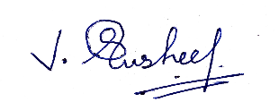

Annexure A

Dry Run Evaluation
1. Question 1 – Breadth-First Search (BFS)
Consider the following graph: A
/ \
B C
/ \ / \
D E F G
Task: Starting from node A, perform a Breadth-First Search (BFS). Complete the following table.
Iteration | Queue | Visited Node
1
2
3
4
5
6
7
Questions:
- Write the BFS traversal order.
- Show the queue contents after each iteration.

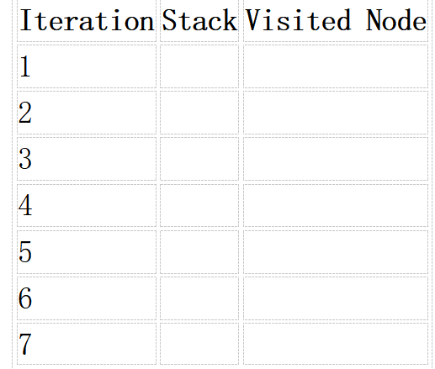
2. Depth-First Search (DFS) Using the same graph,
A
/ \
B C
/ \ / \
D E F G
Perform Depth-First Search (DFS) starting from A.
Complete the table.
- Initial State :
1 3 6
5 0 2
4 7 8

Goal State :
1 2 3
4 5 6
7 8 0

Task
Trace Breadth-First Search (BFS) until the goal state is reached.
Fill in the table.
Iteration | Current State | Queue Before Expansion | Queue After Expansion
1
2
3
4
5

Questions
- Which node is expanded in each iteration?
- How many states are generated in total?
- Write the complete solution path from the initial state to the goal state.
- Why does BFS always find the shortest solution in an unweighted 8-puzzle problem?

ANSWERS

1. Breadth-First Search (BFS) on the Given Tree

BFS Traversal Order:
A, B, C, D, E, F, G

Table (Queue before expansion, Node expanded):
Since it's a tree, we can represent the queue before processing the node at the front.

Iteration | Queue (Before Expansion) | Visited Node (Expanded)
1 | [A] | A
2 | [B, C] | B
3 | [C, D, E] | C
4 | [D, E, F, G] | D
5 | [E, F, G] | E
6 | [F, G] | F
7 | [G] | G

2. Depth-First Search (DFS) on the Given Tree

DFS Traversal Order:
A, B, D, E, C, F, G

Table (Using a Stack - LIFO):
We will assume we add children to the stack in left-to-right order (so the rightmost child is explored first). To get the order A, B, D, E, C, F, G, we must push children onto the stack so that the left child is on top. This means we push right child first, then left child.

Iteration | Stack (Before Expansion) | Visited Node (Expanded)
1 | [A] | A
2 | [C, B] | B
3 | [C, E, D] | D
4 | [C, E] | E
5 | [C] | C
6 | [G, F] | F
7 | [G] | G

3. BFS for the 8-Puzzle Problem

Initial State:
text
1 3 6
5 0 2
4 7 8
Goal State:
text
1 2 3
4 5 6
7 8 0
Trace of BFS:
Here is the trace of the first few iterations until the goal is reached.

Iteration | Current State (Expanded) | Queue Before Expansion | Queue After Expansion
1 | Initial  1 3 6  5 0 2  4 7 8 | [Initial] | [State1, State2]  (Move blank up, Move blank down - only 2 valid moves)
2 | State1 (Blank Up)  1 0 6  5 3 2  4 7 8 | [State1, State2] | [State2, State3, State4]  (Expands to 2 new states)
3 | State2 (Blank Down)  1 3 6  5 7 2  4 0 8 | [State2, State3, State4] | [State3, State4, State5, State6]  (Expands to 2 new states)
4 | State3  0 1 6  5 3 2  4 7 8 | [State3, State4, State5, State6] | [State4, State5, State6, State7, State8]
5 | State4  1 3 6  0 5 2  4 7 8 | [State4, State5, State6, State7, State8] | [State5, State6, State7, State8, State9, State10]
... | ... | ... | ...

1.Which node is expanded in each iteration?
The "Current State" column in the table above shows the node expanded in iterations 1 through 5. BFS continues in this manner.

2. How many states are generated in total?
This is difficult to calculate precisely without running the algorithm. In the worst case for the 8-puzzle, BFS can generate 181,440 states. However, since the goal is relatively close (it requires 4 moves: Blank Left, Up, Left, Up), the actual number generated will be much less, probably in the low hundreds.

3. Write the complete solution path from the initial state to the goal state.

The solution path from the initial state to the goal state is:
- Initial State
text
1 3 6
5 0 2
4 7 8
- Move Blank Left
text
1 3 6
0 5 2
4 7 8
- Move Blank Up
text
1 3 6
4 5 2
0 7 8
- Move Blank Left
text
1 3 6
4 5 2
7 0 8
- Move Blank Up (Goal State)
text
1 2 3
4 5 6
- 8 0

4.Why does BFS always find the shortest solution in an unweighted 8-puzzle problem?
BFS explores nodes in order of their depth from the root (the initial state). It explores all nodes at depth 'd' before exploring any nodes at depth 'd+1'. Therefore, the first time it encounters the goal state, it must be at the shallowest possible depth. Since all moves have a uniform cost (each move costs 1), the shallowest depth corresponds to the minimum number of moves, guaranteeing the shortest solution.

RUBRICS FOR CALCULATION

Criteria | Weightage (%) | Level 4 – Exemplary (4) | Level 3 – Proficient (3) | Level 2 – Developing (2) | Level 1 – Beginning (1)
Understanding of Search Problem | 20 | Clearly understands the search problem, initial state, goal state, and search strategy. | Understands the problem with minor misunderstandings. | Demonstrates partial understanding of the search problem. | Shows little or no understanding of the search problem.
State Expansion and Dry Run Execution | 30 | Correctly traces every iteration, expands nodes accurately, and maintains the Queue/Stack/Priority Queue without errors. | Performs most iterations correctly with minor mistakes in state expansion or data structure updates. | Performs only some iterations correctly; several errors in tracing or node expansion. | Unable to correctly perform the dry run or expand states.
Application of Search Algorithm | 20 | Applies the selected algorithm (BFS/DFS/UCS) correctly, following all algorithmic rules. | Applies the algorithm correctly with a few procedural errors. | Applies only basic algorithm steps with noticeable mistakes. | Fails to apply the correct search algorithm.
Accuracy of Solution Path | 20 | Identifies the correct traversal order/solution path and goal state with proper justification. | Solution path is mostly correct with minor errors. | Partially correct solution path; goal may not be reached correctly. | Incorrect or incomplete solution path.
Presentation and Logical Reasoning | 10 | Queue/Stack/Priority Queue updates, state diagrams, and explanations are neat, organized, and logically presented. | Presentation is clear with minor organizational issues. | Limited explanation and organization; reasoning is partially clear. | Poor presentation with unclear or missing reasoning.

